**MYSQL TEST Test steps and results**

1. 1. Download and install the latest version according to the operating system MYSQL Workbench

<https://dev.mysql.com/downloads/workbench/>

1. Run MYSQL Workbench

Effect screenshot

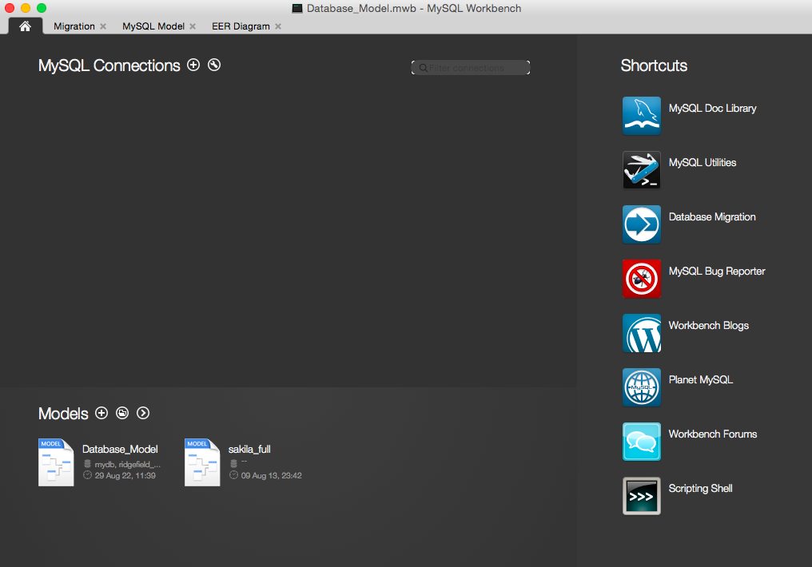

1. Click the red plus sign in the picture below

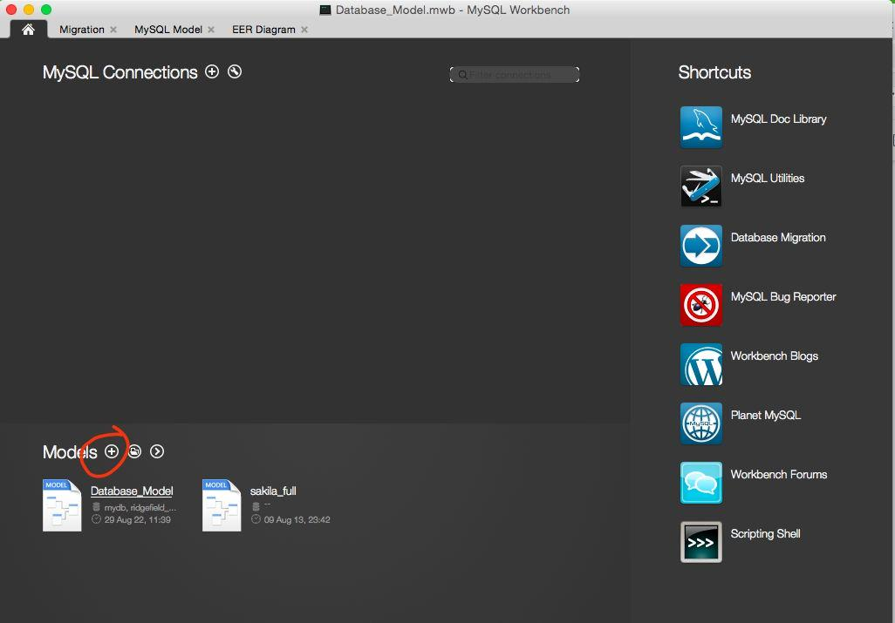

1. The interface will pop up a new page

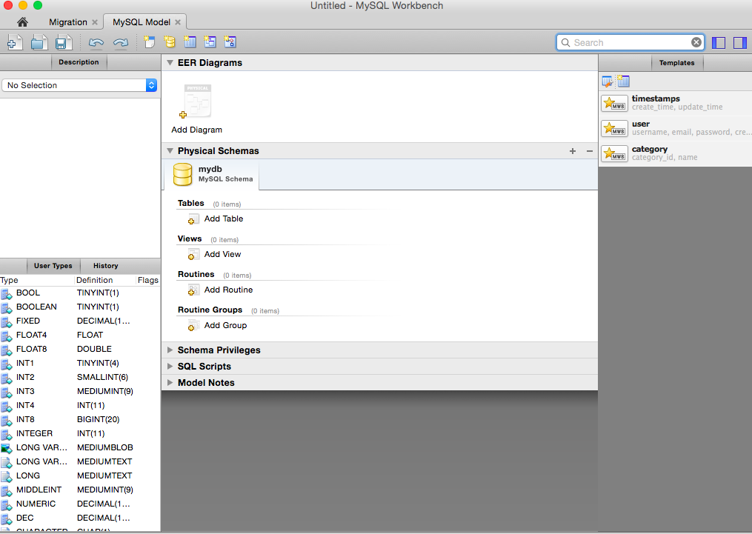

1. Click on the red symbol in the picture below

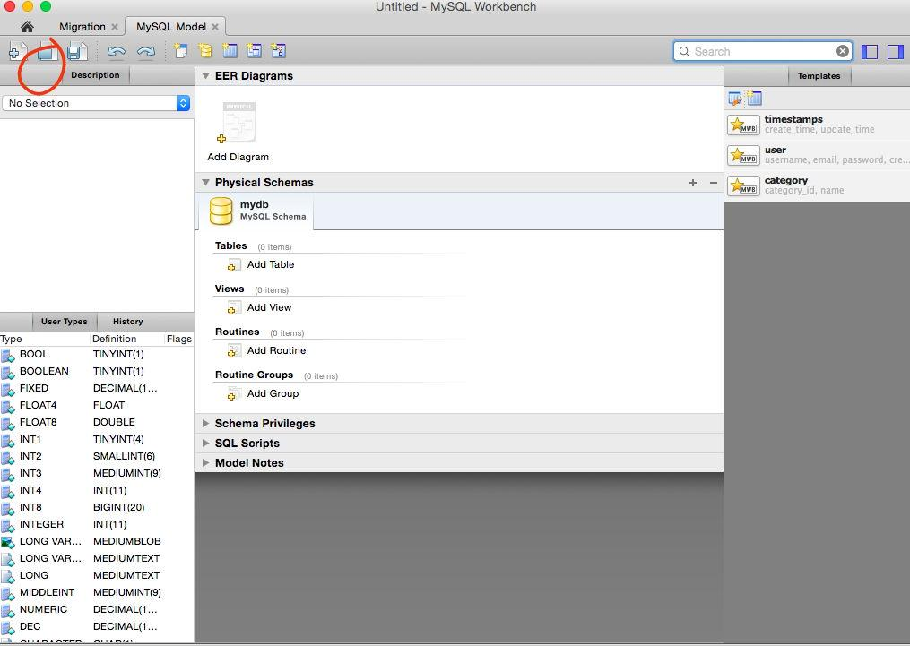

Then select the mwb file (Database_Model.mwb) in the pop-up file selector and click open

After that, the interface will change to the following effect to prove that the database has been imported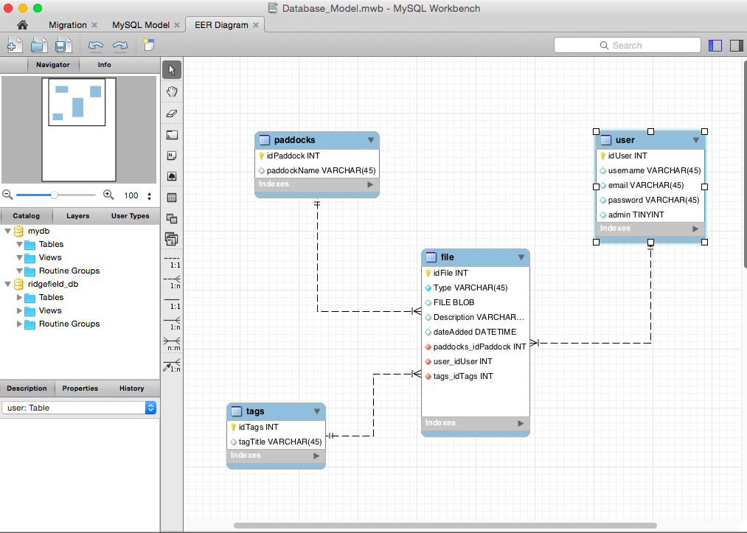

1. Double-click the user chart on the right, then click the insert option below, then click the red symbol in the upper right corner, select the data file (user.csv) to import in the pop-up file selector, and then prove the data when each row of data appears in the table. Import successful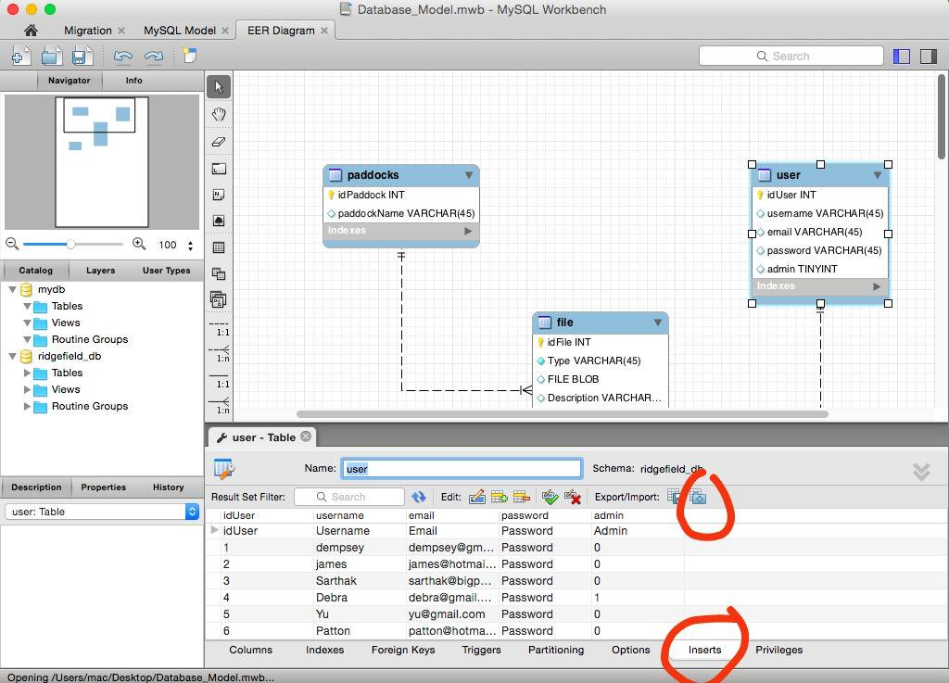
2. Double-click the file chart on the right, then click the insert option below, then click the red symbol in the upper right corner, select the data file (file.csv) to be imported in the pop-up file selector, and then when each row of data appears in the table Prove that the data import was successful
3. Double-click the tags chart on the right and click the insert option at the bottom, then click the red symbol in the upper right corner, select the data file (tags.csv) to be imported in the pop-up file selector, and then when each row of data appears in the table Prove that the data import was successful

9. The database and table data are imported normally